Contents

How to set up the system 2

How to use the system 3

# How to set up the system

Firstly, we have to download the WAMP server on the system to connect the user data with My SQL database.

Than we have tocreate a database in PHP my Admin and Create a Different Tables named as users, circle, book, circle_ book and circle _userand save it in to the www directory to import the files from a local host in PHP My Admin and it will save all the data in the database called “shared db “as Shawn in the figure a below.

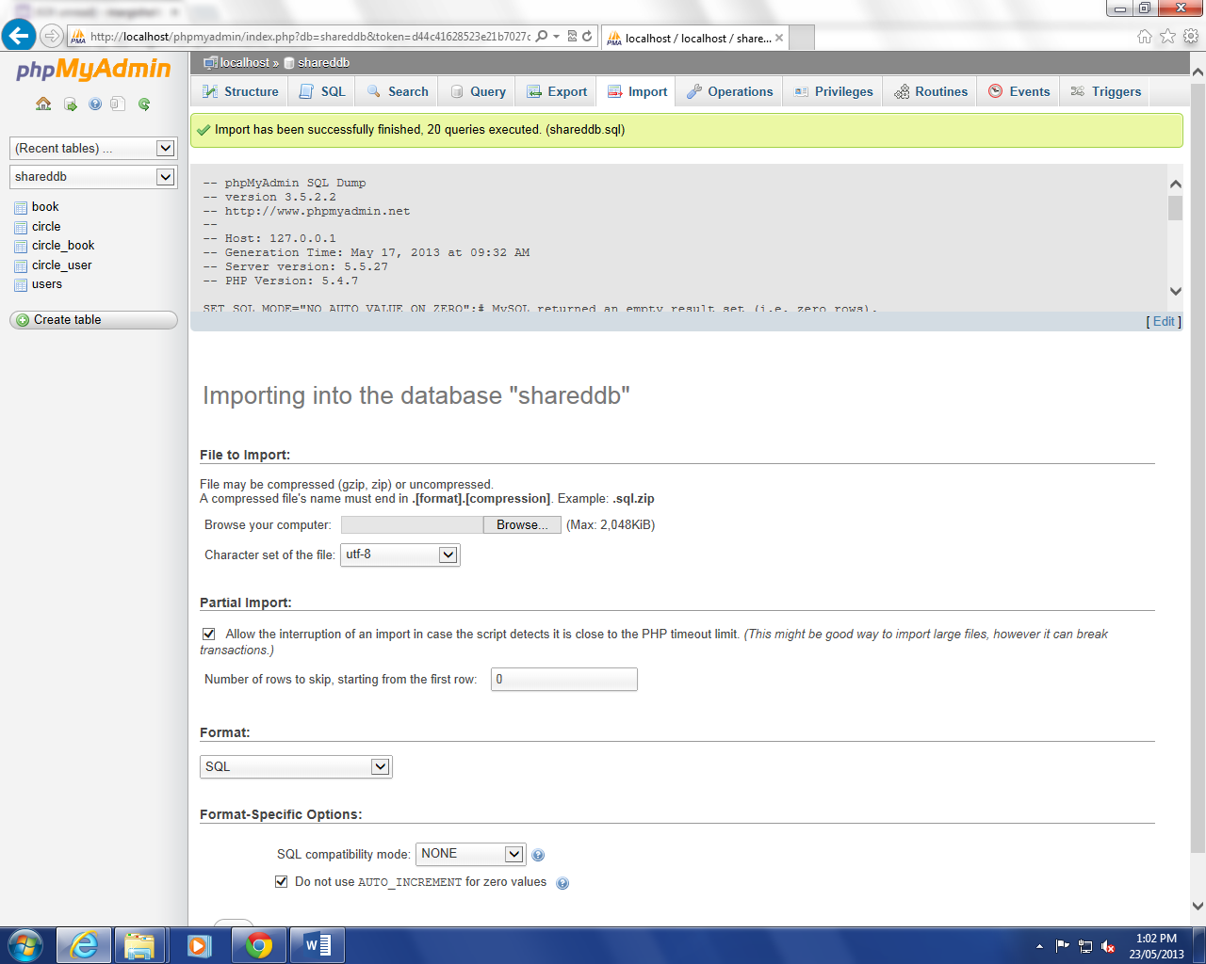

**(Figure a-Importing database in phpMyAdmin Figure 1)**

* So whatever data like user name and password user will enter it will save in to the database called “shareddb” . We also have a default username and password for all users which is “admin “as a uses name and “admin1” as a password.

# How to use the system

* **Home page-** Our website is called as “IDEAL BOOK SHELF”. To know more about our website and all other information user has to read all the information has given on the home page as Shawn in the (figure 1 )below.

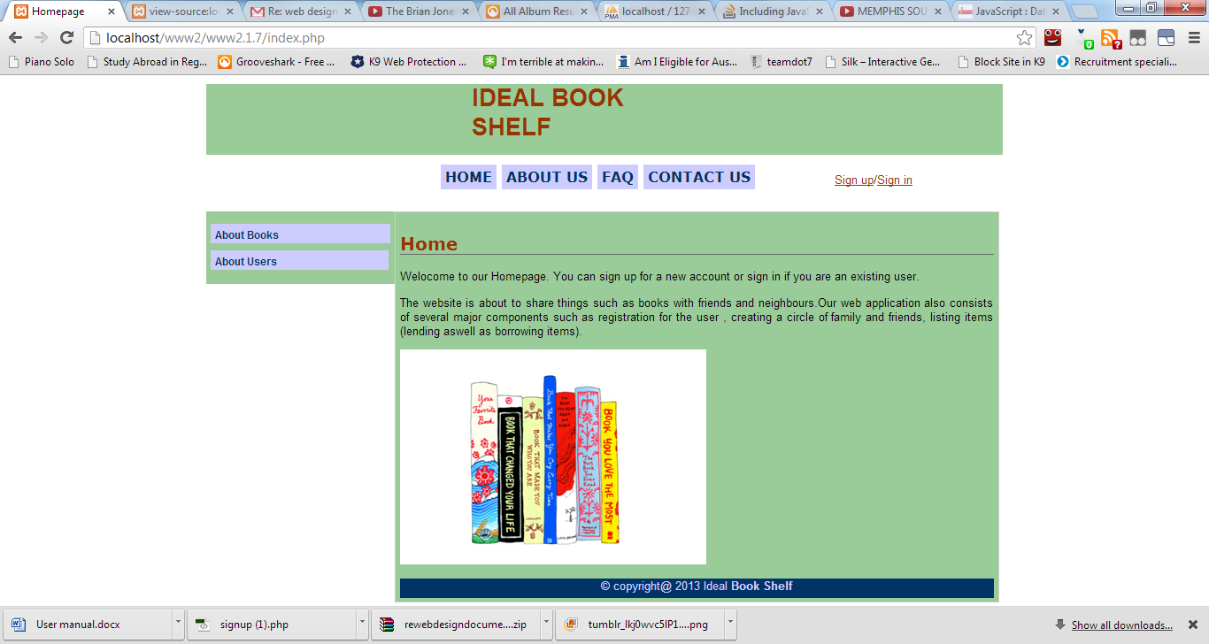

**(Figure 1- Homepage page)**

* **About Books page-** On this page we have given the more information about the books that user can simply read as Shawn in the below (figure 2) and sign up in to the system easily.

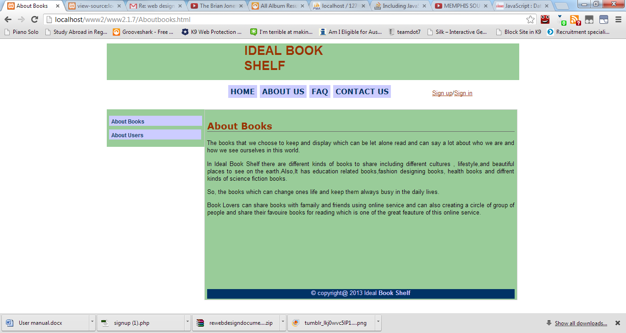

**(Figure 2- About Books page)**

* **About Users page**- About users page giving all the information about the users that how user can sign in or sign up the page as shown in the below ( figure 3).

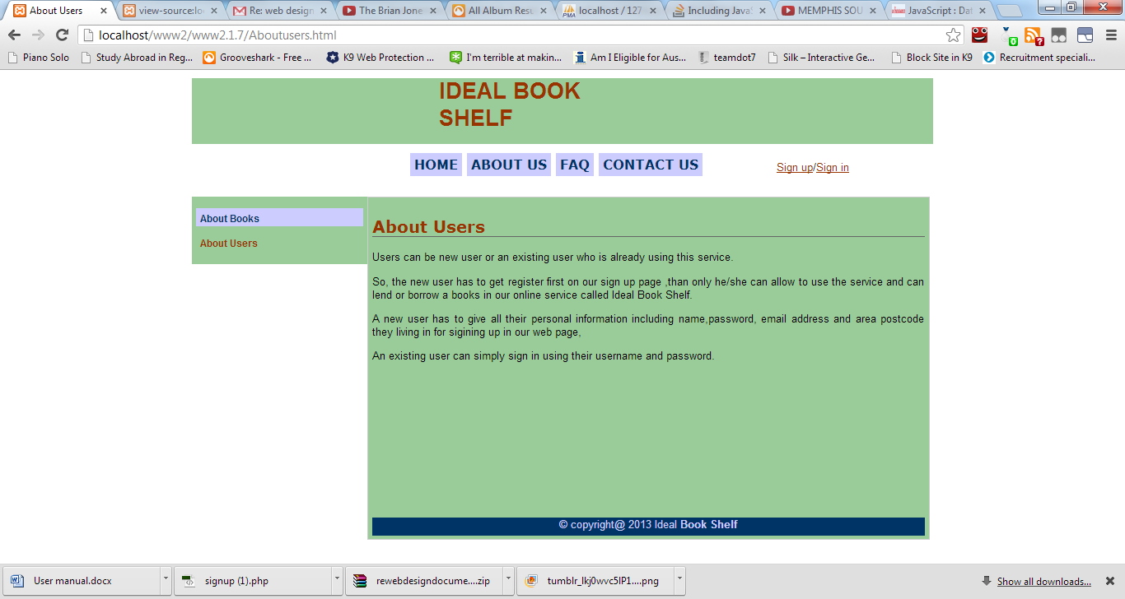

**(Figure 3- About Users Page)**

* **About US page** – This page is giving information about the over website’s history like when we had started our website and what is the purpose of making our website called “IDEAL BOOK SHELF”. For more information on the page showing in the (figure 4) below.

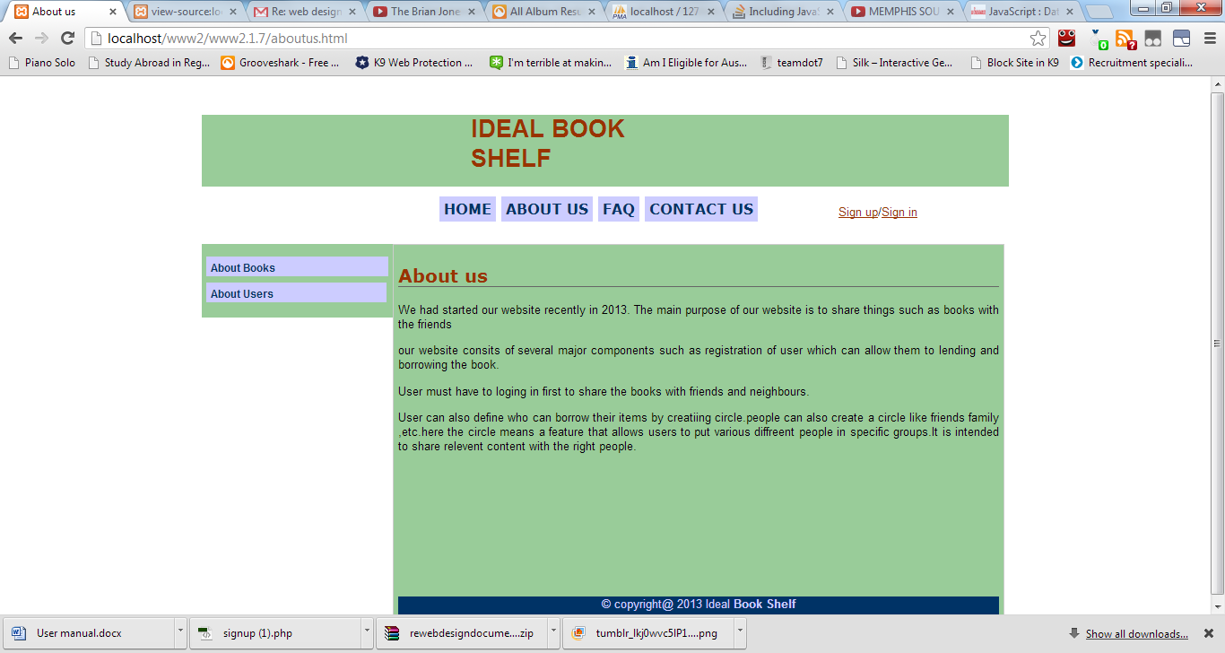

**(Figure 4 – About Us Page)**

* **FAQ Page**- This page is giving all the answers to the user about the questions which can comes up in his/her mind while using a system as shown in the (figure 5 )below.

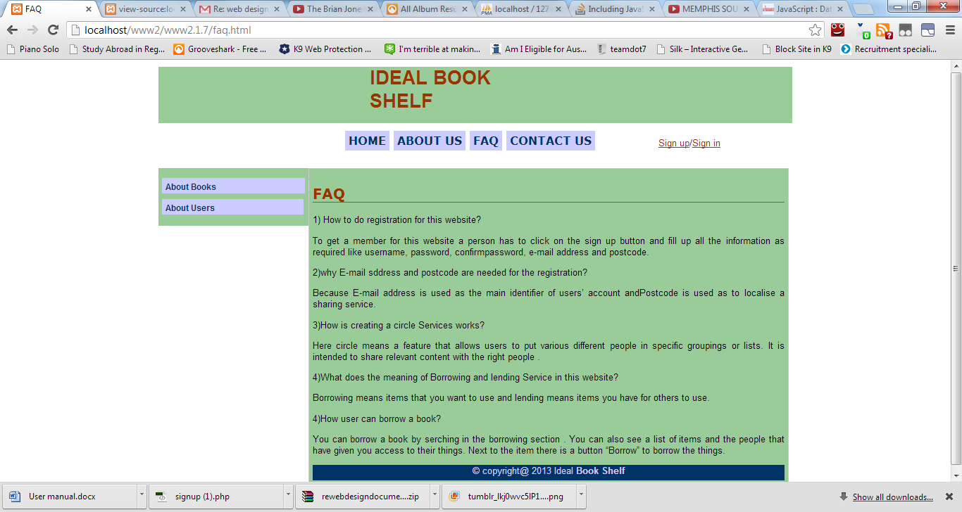

**(Figure 5 – FAQ Page)**

* **Contact Us page**- Contact us page giving an information to the user about where we are situated and our contact numbers so if any doubt user can contact us or see us as page shown in the( figure 6) below.

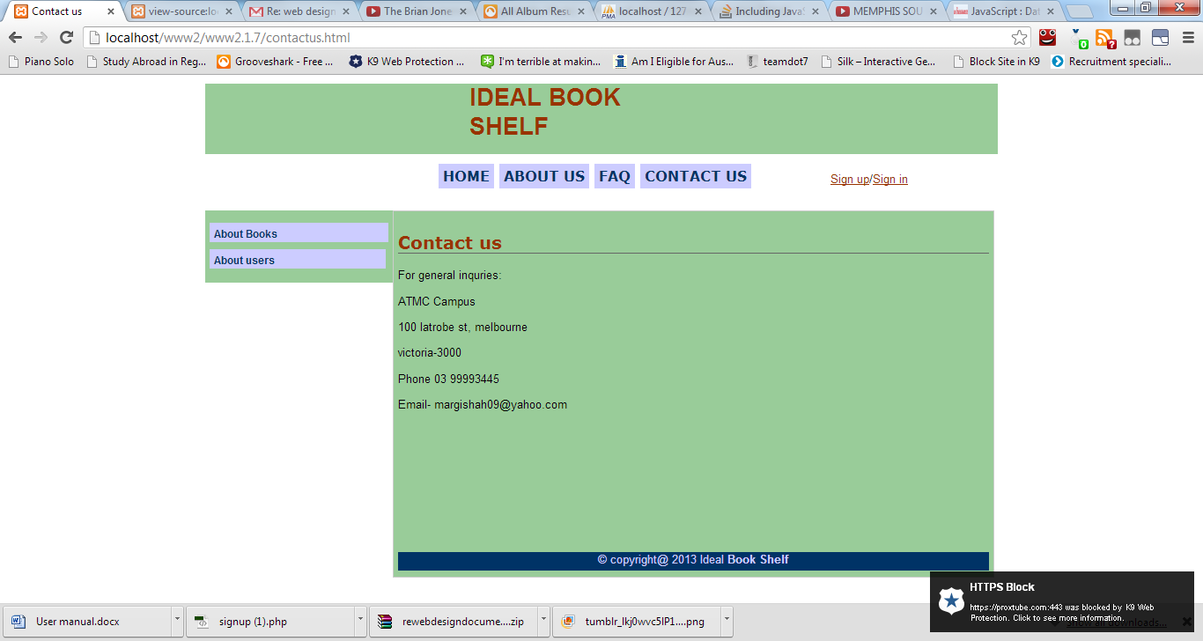

**(Figure 6 –Contact US Page)**

**Sign up a new Account**- To use a system first of all, new users need to register by creating an account and enter all the information required as name, password, confirm password, email address and postcode, As Shawn in the bellow (figure 7.) Also all the information user enter should be correct and password and confirm password must match to sign up the page. Post code is use as to localise a sharing service.

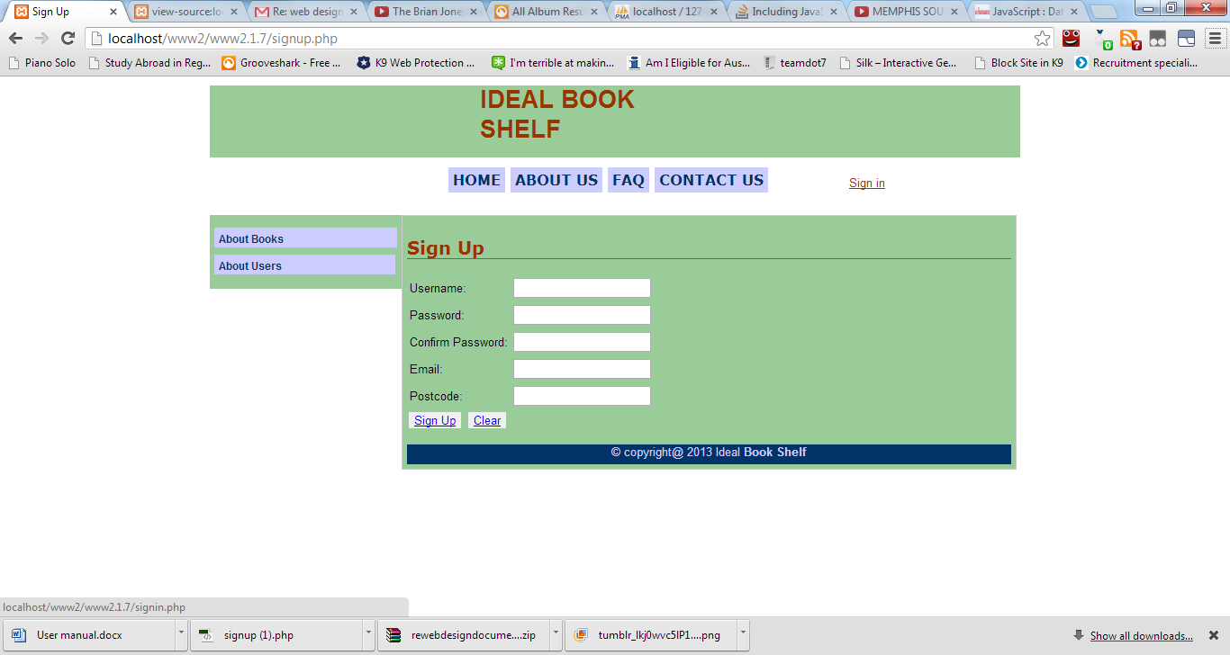

**(Figure 7 – Sing Up page)**

* **Sign in in to the account**- An existing users can use the system by simply enter their user name and password as shown in the (figure 8) below.

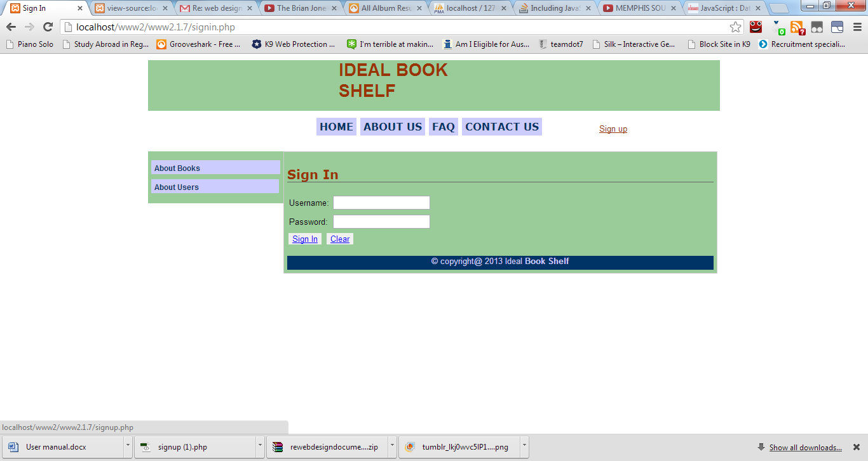

**(Figure 8 – Sign In Page)**

* Create a Circle –once a user has sign up in to the system, User can define who can borrow their items by creating a circle as shown in the (figure 9) .user can create a circle like friends and family etc. Once a user has created a circle than he/she can add another users to a circle by entering their email address. This feature on our system allows users to put various different people in specific groups or lists and it is intended to share relevant books with the right people.

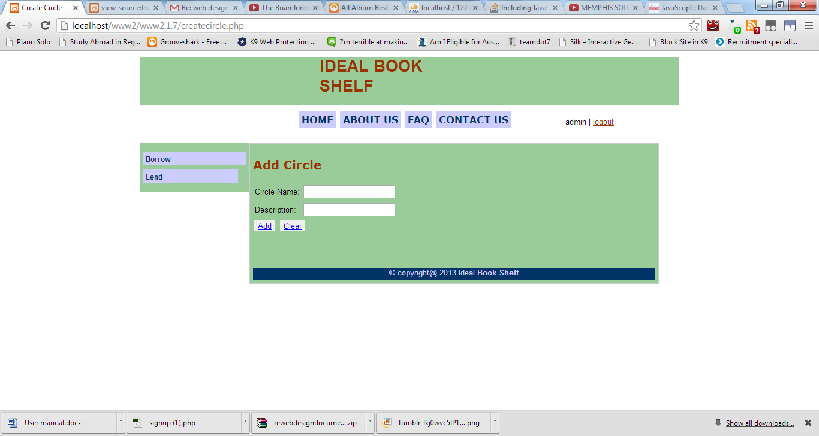

**(Figure 9 – Add Circle Page)**

* **Borrow a book**- for borrowing a book an user has to sign in in to account and can borrow a book that he/she want to use. An user can borrow other people’s items by searching in the borrowing section .user can also see the list of books and the people that have given you access to their things .Next to the item there is a button “Borrow” to borrow the things. As shown in the (figure 10) below.

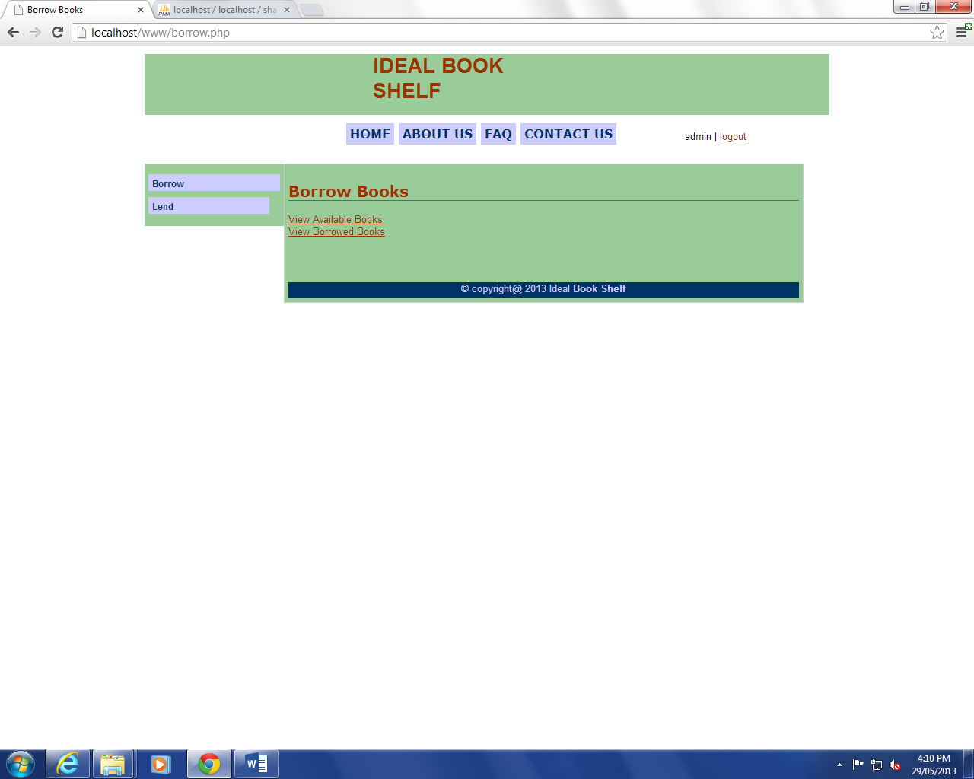

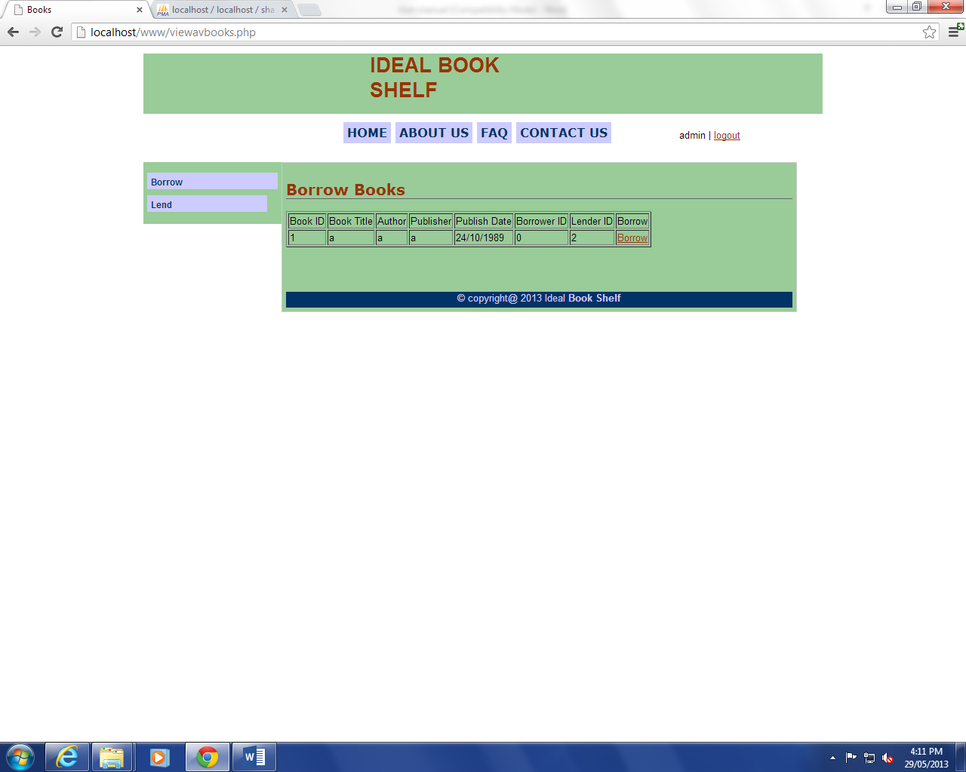

**(Figure 10- Borrow a book page)**

* **Lend a book**- user can lend books in to the system for others to use. User should be able to add items and its description for lending. To remove items, there is a remove button next to the item so if user can remove the item easily if he don’t want that item for other’s to borrow as shown in the ( figure 11) below. Also, once user has added books for lending, can decide who can borrow the items.

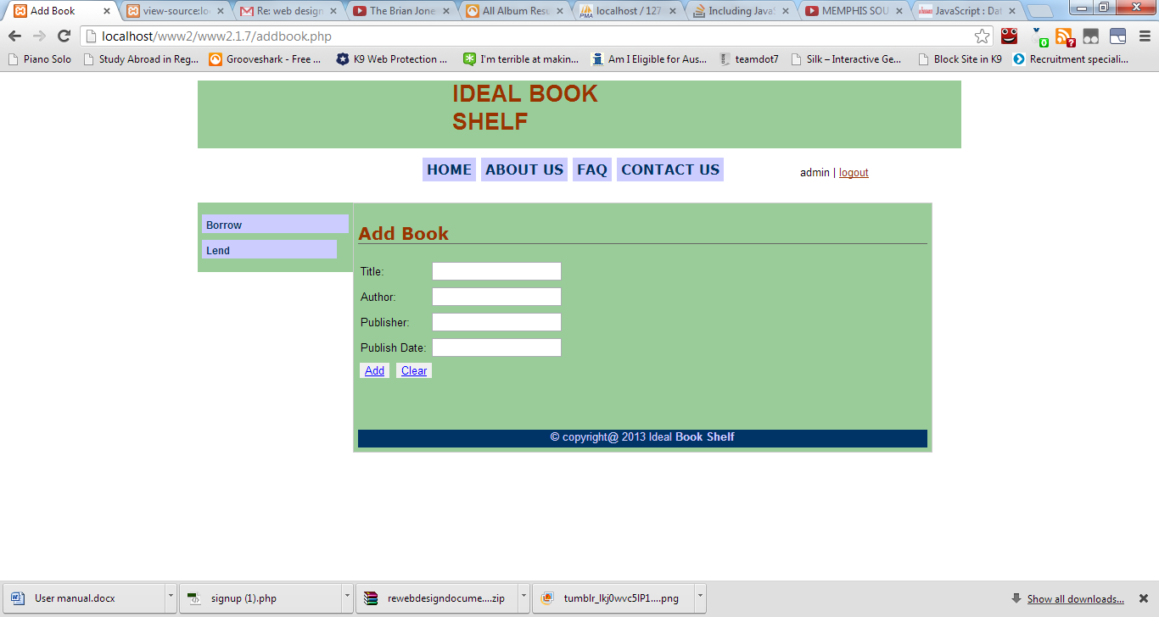

(**Figure 11 – Add Book Page)**

* **Sign out** – If user wish to leave the page than he/she simply has to click on sign out button as shown in the (figure 12).